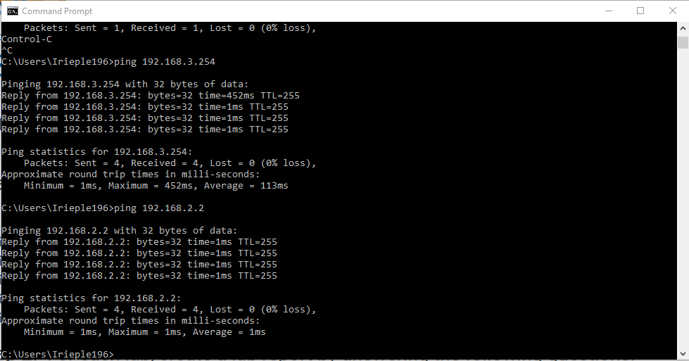

WAN works cuz routers can ping each other.

Comp on network 1 and 3 2 is wan.

NO SHUT